**Java Web开发**

**实验三**

**作业报告**

|  |  |
| --- | --- |
| 学 院 | 计算机 |
| 所在系 班 级 | 2017软件工程系9班 |
| 学 号 姓 名 | 03170609 祝志豪 |
| 指 导 教 师 | 郭晓燕 |
| 完 成 时 间 | 2019年3月25日 |

# 实验题目

将第二章实训题的第二题，登录页面，提交用户名、密码，若用户名不为空字符串且长度在6-8位间，密码不为，空长度为6位，则登录成功，显示“***（用户名）登录成功！”，否则显示“***登录失败”。

# 分析与设计

根据题目要求，计划设计几个文件来完成实验，每个文件的名字、作用。如果是类，要求写出类的变量和方法

# 关键源码（部分）

<!DOCTYPE html>

<html>

<head>

<title>Register.html</title>

<meta name=*"keywords"* content=*"keyword1,keyword2,keyword3"*>

<meta name=*"description"* content=*"this is my page"*>

<meta name=*"content-type"* content=*"text/html; charset=GB2312"*>

</head>

<body>

<form method=*'port'* action=*'dologin'*>

用户名：<input type=*'text'* name=*'username'* ><br>

密码：<input type=*'password'* name=*'password'* ><br>

<input TYPE=*"submit"* value=*"登录"* name=*"submit"*>

</form>

</body>

</html>

import java.io.IOException;

import java.io.PrintWriter;

import javax.servlet.ServletException;

import javax.servlet.annotation.WebServlet;

import javax.servlet.http.HttpServlet;

import javax.servlet.http.HttpServletRequest;

import javax.servlet.http.HttpServletResponse;

@WebServlet("/dologin")

public class dologin extends HttpServlet {

public dologin() {

super();

}

public void destroy() {

super.destroy(); // Just puts "destroy" string in log

// Put your code here

}

public void doGet(HttpServletRequest request, HttpServletResponse response)

throws ServletException, IOException {

this.doPost(request, response);

}

public void doPost(HttpServletRequest request, HttpServletResponse response)

throws ServletException, IOException {

request.setCharacterEncoding("UTF-8");

response.setContentType("text/html;charset=UTF-8");

String username = request.getParameter("username");

String password = request.getParameter("password");

if((username.length()==8||username.length()<8) && username !="" && (6==username.length()||6<username.length()) && password.length() ==6 &&password !="")

{

request.getRequestDispatcher("success.jsp")

.forward(request, response);

}

else

{

request.getRequestDispatcher("fail.jsp")

.forward(request,response);

}

}

public void init() throws ServletException {

// Put your code here

}

}

<%@ page language=*"java"* import=*"java.util.*"* pageEncoding=*"GB2312"*%>

<%

String path = request.getContextPath();

String basePath = request.getScheme()+"://"+request.getServerName()+":"+request.getServerPort()+path+"/";

%>

<!DOCTYPE HTML PUBLIC "-//W3C//DTD HTML 4.01 Transitional//EN">

<html>

<head>

<base href=*"*<%=basePath%>*"*>

<title>My JSP 'succes.jsp' starting page</title>

<meta http-equiv=*"pragma"* content=*"no-cache"*>

<meta http-equiv=*"cache-control"* content=*"no-cache"*>

<meta http-equiv=*"expires"* content=*"0"*>

<meta http-equiv=*"keywords"* content=*"keyword1,keyword2,keyword3"*>

<meta http-equiv=*"description"* content=*"This is my page"*>

<!--

<link rel="stylesheet" type="text/css" href="styles.css">

-->

</head>

<body>

<% request.setCharacterEncoding("GB2312");

String username=request.getParameter("username");

out.println("<p>"+username+" 登陆成功</p>");

%>

</body>

</html>

<%@ page language=*"java"* import=*"java.util.*"* pageEncoding=*"GB2312"*%>

<%

String path = request.getContextPath();

String basePath = request.getScheme()+"://"+request.getServerName()+":"+request.getServerPort()+path+"/";

%>

<!DOCTYPE HTML PUBLIC "-//W3C//DTD HTML 4.01 Transitional//EN">

<html>

<head>

<base href=*"*<%=basePath%>*"*>

<title>My JSP 'fail.jsp' starting page</title>

<meta http-equiv=*"pragma"* content=*"no-cache"*>

<meta http-equiv=*"cache-control"* content=*"no-cache"*>

<meta http-equiv=*"expires"* content=*"0"*>

<meta http-equiv=*"keywords"* content=*"keyword1,keyword2,keyword3"*>

<meta http-equiv=*"description"* content=*"This is my page"*>

<!--

<link rel="stylesheet" type="text/css" href="styles.css">

-->

</head>

<body>

<% request.setCharacterEncoding("GB2312");

String username=request.getParameter("username");

out.println("<p>"+username+" 登录失败</p>");

%><br>

</body>

</html>

# 运行效果图

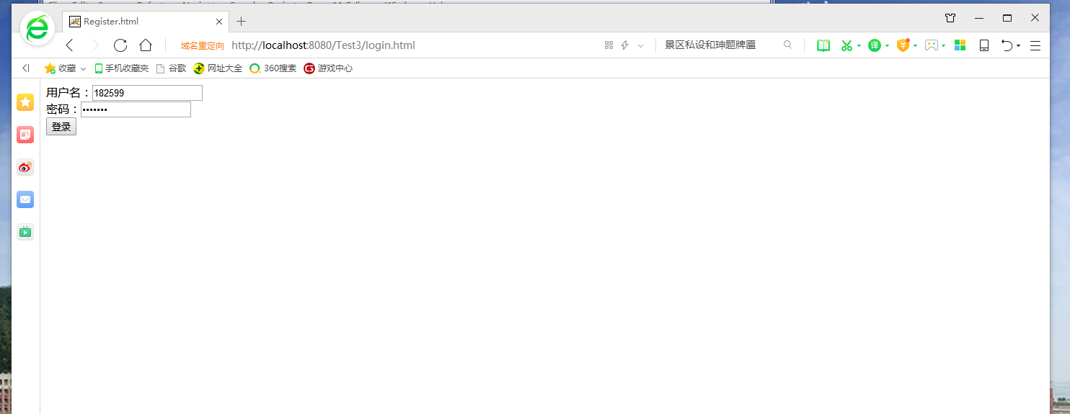

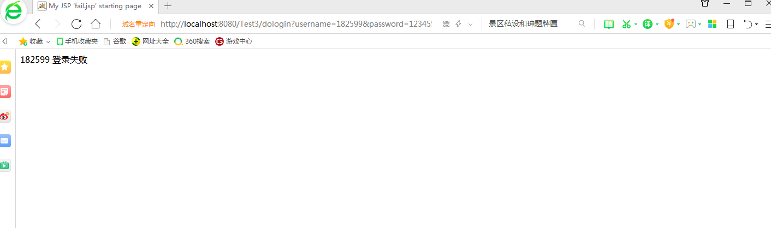

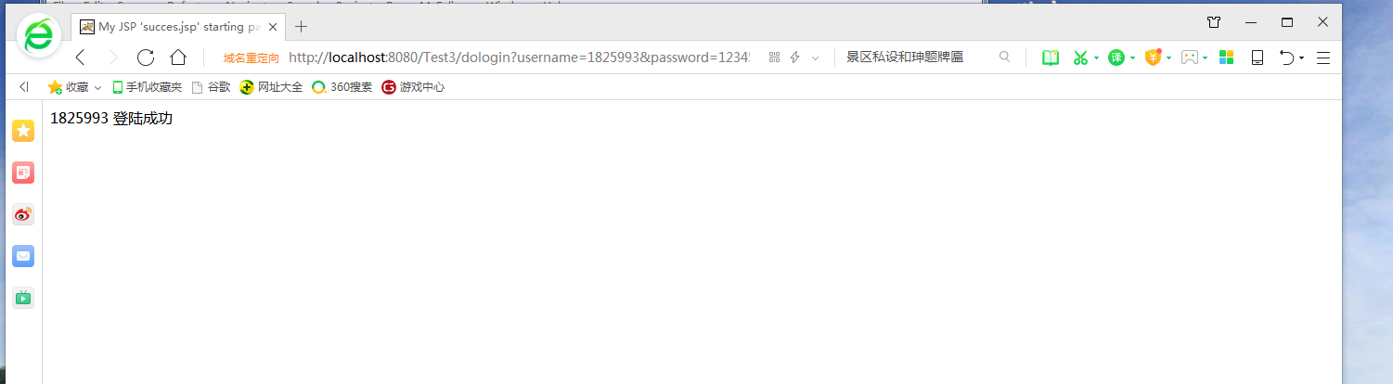

# 收获与问题